

Wellbeing Policy.

2025 - 2028

St. Mogue’s College,
Bawnboy,
Co. Cavan.
Telephone: 9523112

DEIS Band 2 school with an enrolment of 310 pupils 2024. Mixed school, non-denominational under the trustee of CMETB.

This policy is informed by:

- The mission statement of St. Mogue’s College
- The SPHE policy
- The Code of Behaviour
- The Child Protection Policy/ Child Safeguarding Statement
- The Internet Acceptable Usage Policy
- Relationships and Sexuality Education Policy.

Mission Statement:
St. Mogue’s College seeks to achieve a safe, respectful learning and working environment so that participants can achieve their potential in partnership with relevant agencies.
With this in mind and in accordance with the Department of Education and Science, the following Wellbeing Policy has been devised in consultation with staff and parents. St. Mogue’s College is committed to implementing this comprehensive wellbeing Programme.

Rationale for the Policy

This policy has been introduced in order to allow the school to adequately respond to the changing and diverse needs of our pupils. St. Mogue’s College is committed to the nurturing of the whole person so that they may be guided with care and respect to respond to the demands of modern life with resilience, optimism and a feeling of ownership.

Goals of the policy

The goal of wellbeing is human flourishing, and flourishing rests on the following:
Positive emotion engagement, relationships, meaning, and accomplishment.
The goal of this policy document is to outline clearly the school’s approach to the provision of wellbeing for all members of the St Mogue’s community, setting out the structure and supports that are in place both within the curriculum and the wider school community. This policy will outline our belief that everybody in the school community is valued and has an opportunity to flourish through the following common approach.

- All staff contribute to promoting a caring and inclusive environment within the school that is supportive of school wellbeing.
- There is a shared vision and understanding of what student wellbeing means, which emphasises strengths and capacities.
- Respectful and caring relationships are fostered between staff and students, students and students, and staff and parents.
- There are structures in place designed to support the wellbeing of pupils.
What is Wellbeing?

Wellbeing is present when students realise their abilities, take care of their physical wellbeing, can cope with the normal stresses of life, and have a sense of place and belonging to a wider community. Wellbeing indicators are thus as follows – Active, Responsible, Connected, Resilient, Respected, and Aware. These indicators are representative of the following key skills that St Mogue’s strives to develop in our pupils:

- Being a confident and skilled participant in physical activity
- Being able to take action to protect and promote their wellbeing and that of others
- Making healthy eating choices.
- Knowing when and where their safety is at risk and enabling them to make the right choices.
- Feeling connected to their school, friends, community and the wider world
- Understanding how their actions and interactions impact on their own wellbeing and that of others, in local and global contexts.
- Feeling confident in themselves and having the coping skills to deal with life’s challenges.
- Knowing where they can go for help.
- Believing that, with effort, they can achieve.
- Showing care and respect for others.
- Having positive relationships with friends, peers, and staff members
- Feeling listened to and valued
- Being aware of their thoughts, feelings, and behaviours, and being able to make sense of them.
- Being aware of their personal values, and able to think through their decisions.
- Being aware of themselves as learners, and knowing how they can improve.

Recognising the Importance of Relationships for Wellbeing in School

St Mogue’s recognises that true wellbeing can only be assured through the promotion and development of positive, nurturing and respectful relationships within our school community. We strive to achieve this in the following ways:

- Ensuring that student-teacher relationships are friendly, caring and respectful
- Making sure that staff are fully aware that they may be the one adult that a student turns to for support and help during a difficult time.
- Fully informing students as to where to get support and how to access the care structures in the school.
- Resolving behaviour issues with care, respect and consistency
- Ensuring that there is a shared vision and understanding of what student wellbeing means which emphasises strengths and capacities.
- Encouraging students to show respect, care and concern for each other so that they feel safe and supported amongst their peers.
- Recognising that staff are entitled to feel supported and cared for amongst their colleagues.
- Providing forums for students so that their voices may be heard, and they are involved in making decisions about their life in school.
- Making sure that students know that their feedback is valued and, where appropriate, acted upon.
- Ensuring that parents feel welcome, respected, and listened to as partners in the education of their children.
- Sharing information with parents as to how they can support their child’s wellbeing
- Maintaining strong links with the local community.

Wellbeing & the Curriculum
Here at St Mogue’s we have chosen to strongly prioritise and highlight wellbeing within our school community.
This is reflected strongly in our curricular provision:

- There is a coherent and coordinated approach to the provision of CSPE, PE and SPHE as part of the wellbeing programme in Junior Cycle.
- Staff are afforded opportunities to work collaboratively in planning for these subjects and CPD is actively supported.
- Curricular provision is informed by student and parental feedback.
- Guidance-related learning is an important aspect of the wellbeing curriculum in Junior Cycle.
- The guidance counsellor works collaboratively with staff in relation to the wellbeing programme and its implementation.
- The guidance counsellor actively supports students in Junior Cycle through information, assessment and counselling support.

The Framework for Junior Cycle (2015) highlights the necessity for a new area of learning at Junior Cycle Wellbeing. The necessity for the introduction of Wellbeing into post-primary education has been long overdue. This policy has been introduced to ensure the school is responding adequately to the changing and diverse needs of each of our pupils. There are already evident similarities between our own mission statement and the definition of ‘Student Wellbeing’ as outlined in the NCCA guidelines.
‘Student wellbeing is present when students realise their abilities, take care of their physical wellbeing, can cope with the normal stresses of life, and have a sense of purpose and belonging to a wider community.’ (NCCA, 2017)
Education and Wellbeing are inextricably linked.
Within our Wellbeing programme at St. Mogue’s our vision is to enable students to build life skills and develop a strong sense of connectedness to their school and to their community.
St. Mogue’s will endeavour to facilitate the holistic development of each of our students using the six indicators of Wellbeing as the focal point of our actions: Active, Responsible, Connected, Resilient and Respected and Aware.

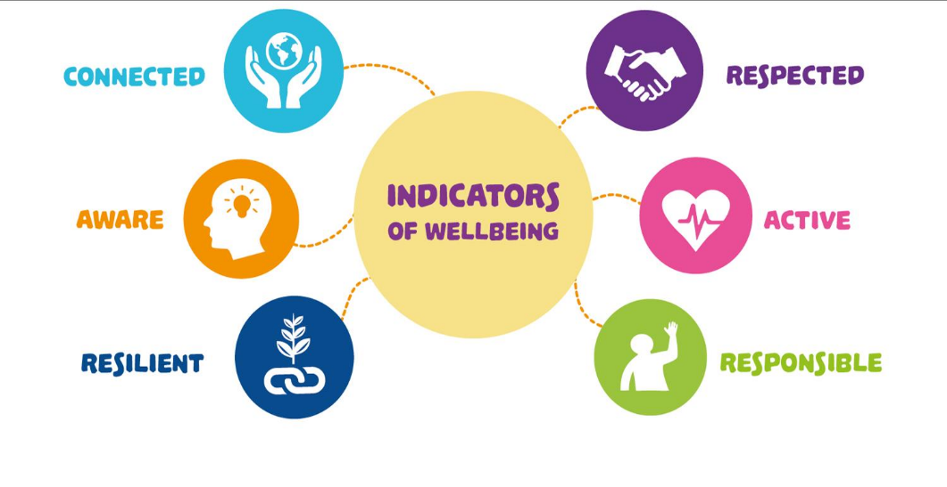

The Structure of the Wellbeing Policy:

The foundation of this policy is based on the Junior Cycle Wellbeing Guidelines and Wellbeing indicators, the aim of which is to support schools in planning and developing a consistent Wellbeing programme. Within St. Mogue’s policy we hope to enhance and develop our understanding, practice and curricula for Wellbeing already existing in school. Through the focus on four aspects of Wellbeing in our school – School Culture, Relationships, Policy & Planning and Curriculum we aim to establish a Wellbeing policy which encompasses the whole school community.

The Four Aspects of Wellbeing in Schools

Wellbeing and the Curriculum at St. Mogue’s College

The curricular aspect of our Wellbeing policy has been discussed at length and devised with the student at the centre of learning in mind. A core group was established between members of management, the curricular and the wellbeing teams. The areas of PE, SPHE, CSPE, Pastoral Care, and Digital Leadership.

At St Mogue’s we believe that a Junior Cycle programme that builds the foundations for Wellbeing:
- Is broad and balanced.
- Provides choice.
- Has meaning and relevance.
- Is enjoyable and engaging.
- Provides opportunities to experience challenge and success.
- Equips students with the knowledge, skills and dispositions to develop as learners and build positive relationships.

Statements of Learning

The learning at the core of junior cycle is described in twenty-four statements of learning. They are central to planning for, the students’ experience of, and the evaluation of the school’s junior cycle programme.
(Framework for Junior Cycle, 2015, page 12)

The following Statements of Learning are particularly applicable to

Wellbeing:

The student has an awareness of personal values and an understanding of the process of moral decision making (SoL 5)

The student values what it means to be an active citizen, with rights and responsibilities in local and wider contexts (SoL 7)

The student has the awareness, knowledge, skills, values and motivation to live sustainably (SoL 10)

The student takes action to safeguard and promote her/his wellbeing and that of others (SoL 11)

The student is a confident and competent participant in physical activity and is motivated to be physically active (SoL 12)

The student understands the importance of food and diet in making healthy lifestyle choices (SoL 13).

Scope of the Wellbeing Policy

Explore current and future avenues for fostering happy, confident, responsible and resilient students who feel connected to St. Mogue’s. Reflect on how we are currently addressing the area of Wellbeing in our school through curricular and extra-curricular provision.

Wellbeing Curriculum Plan

First Year Wellbeing | Details
PE | 1 x 1-hour period
SPHE | 1 x 1-hour period
Pastoral Care | 15 minutes per week
CSPE | 1 x 1 hour per week
Religion | 1 x 1 hour per week
Induction to Secondary School  (4 hours)  Belonging Plus | Students are given tours of the school and shown the offices of their HSCL, principal and deputy principal, as well as the guidance counsellor. They are shown how to use their locker and mobile phone lock. They will be taught how to use their timetable and use their student journal effectively. The teacher will go through the school rules in the code of behaviour and draw their attention to the school’s rules on no physical fighting, anti-bullying procedures and the mobile phone policy.  Induction for incoming First Years, used in SPHE classes to aid the transition.
Second Year Wellbeing | Details
PE | 1 x 1-hour period
SPHE | 1 x 1-hour period
Pastoral Care | 15 minutes per week
CSPE | 1 x 1 hour per week
Religion | 1 x 1 hour per week
Third Year Wellbeing | Details
PE | 1 x 1-hour period
SPHE | 1 x 1-hour period
Pastoral Care | 15 minutes per week
CSPE | 1 x 1 hour per week
Religion | 1 x 1-hour per week

Planning

Explicitly planning for wellbeing in the curriculum and assigning it space on the timetable communicates to students, parents and teachers that this area of learning is important – it makes the school’s concern with wellbeing visible and confirms for students in a very recognisable way that their wellbeing matters. For this reason, the 2017 Wellbeing Guidelines place a strong emphasis on the role that Civic, Social and Political Education (CSPE), physical education (PE), Social, Personal and Health Education (SPHE), guidance and other units of learning can play in supporting learning about wellbeing and learning for wellbeing.

Reviewed

This policy was reviewed by the Board of Management of St. Mogue’s College on 15/9/25.

